Add new Bike use case

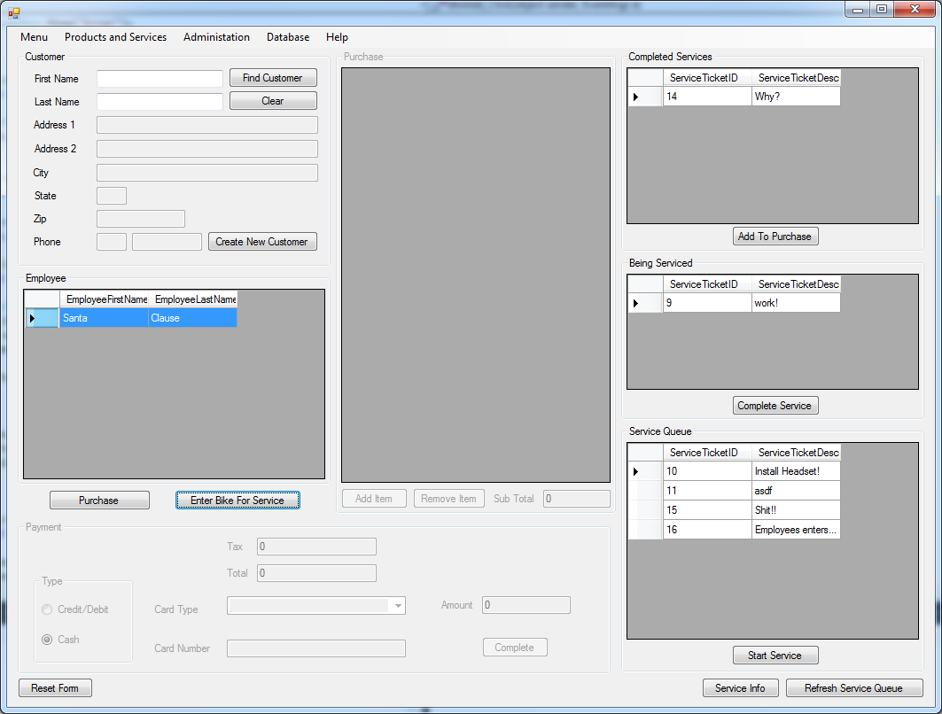

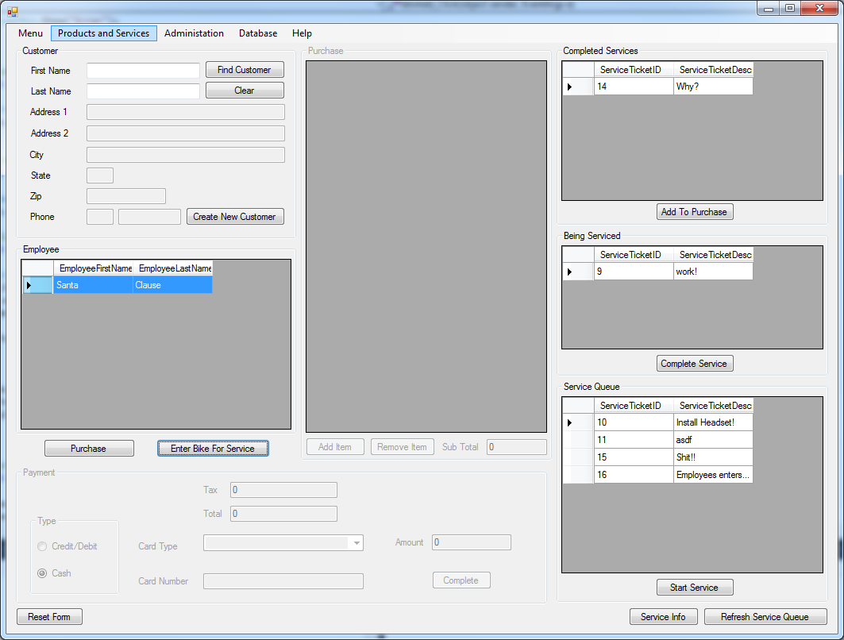

Employee Selects Products and services menu then selects manage New bikes(I tried to get picture with menu open but it wouldn’t stay open) 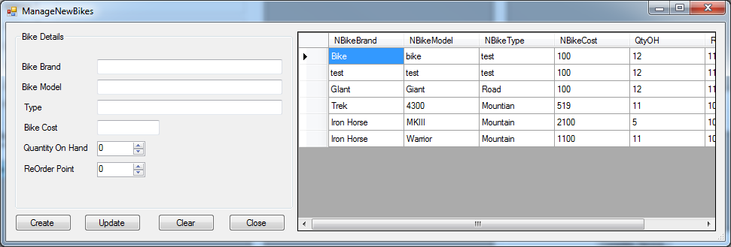

Manage bike windows appears

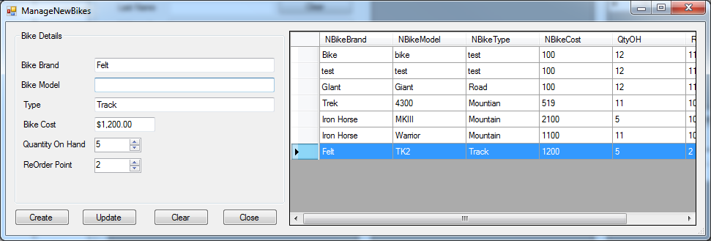

Employee Bike Information But Leaves Model Empty then hits create

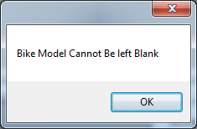

Message for when Bike Model is left blank

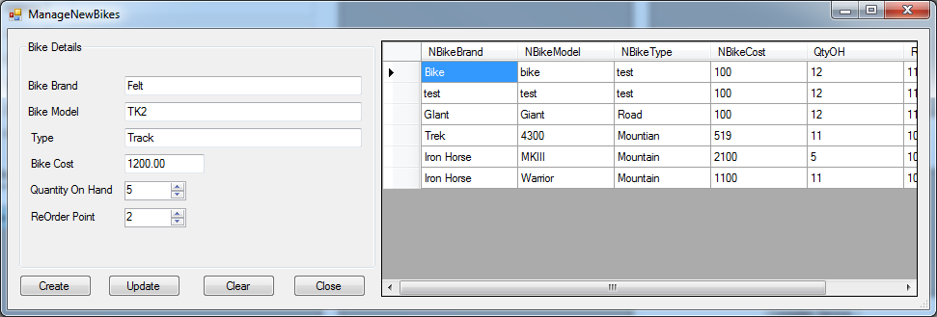

Employee Fixes Bike Model and clicks create button

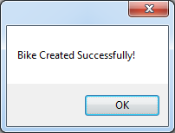

Message saying bike was created successfully

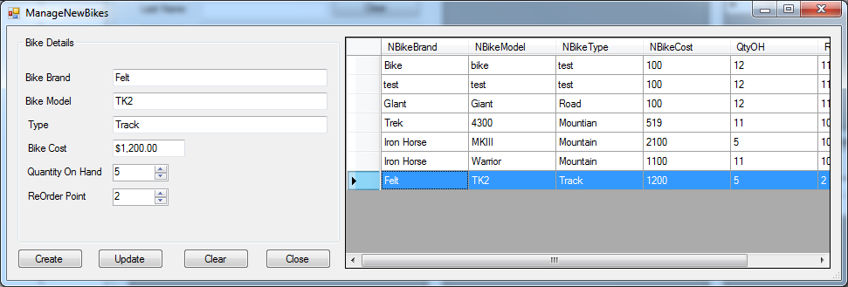

Bike List Reloads and the new bike is visible in bike List